|  |  |  |  |  |  |
| --- | --- | --- | --- | --- | --- |
| **July 2024** | | | | | |
| **Monday** | **Tuesday** | **Wednesday** | **Thursday** | **Friday** | **Saturday** |
|  |  |  |  |  | **1** |
| **1**  **Half Day Summer Camp**  **9:00 am – 12:00 pm**  **Full Day Summer Camp**  **9:00 – 4:00 pm**  **Ages 4 and up** | **2**  **Half Day Summer Camp**  **9:00 am – 12:00 pm**  **Full Day Summer Camp**  **9:00 – 4:00 pm**  **Ages 4 and up** | **3**  **Half Day Summer Camp**  **9:00 am – 12:00 pm**  **Full Day Summer Camp**  **9:00 – 4:00 pm**  **Ages 4 and up** | **4**  **Half Day Summer Camp**  **9:00 am – 12:00 pm**  **Full Day Summer Camp**  **9:00 – 4:00 pm**  **Ages 4 and up** | **5**  **Half Day Summer Camp**  **9:00 am – 12:00 pm**  **Full Day Summer Camp**  **9:00 – 4:00 pm**  **Ages 4 and up** | **6**  **Drop-in**  **9 – 10**  **Birthday**  **Parties** |
| **8**  **Competitive Tryouts**  **8:00 – 9:30**  **Competitive**  **Summer Training**  **10:00 – 12:30**  **Trampoline/ Tumbling**  **2:00 – 3:30** | **9**  **Competitive Tryouts**  **8:00 – 9:30**  **Competitive**  **Summer Training**  **10:00 – 12:30**  **Trampoline/ Tumbling**  **2:00 – 3:30** | **10**  **Competitive Tryouts**  **8:00 – 9:30**  **Competitive**  **Summer Training**  **10:00 – 12:30**  **Trampoline/ Tumbling**  **2:00 – 3:30** | **11**  **Competitive Tryouts**  **8:00 – 9:30**  **Competitive**  **Summer Training**  **10:00 – 12:30**  **Trampoline/ Tumbling**  **2:00 – 3:30** | **12**  **Competitive Tryouts**  **8:00 – 9:30**  **Competitive**  **Summer Training**  **10:00 – 12:30** | **13**  **Drop-in**  **9 – 10**  **Birthday**  **Parties** |
| **15**  **Half Day Summer Camp**  **9:00 am – 12:00 pm**  **Full Day Summer Camp**  **9:00 – 4:00 pm**  **Ages 4 and up** | **16**  **Half Day Summer Camp**  **9:00 am – 12:00 pm**  **Full Day Summer Camp**  **9:00 – 4:00 pm**  **Ages 4 and up** | **17**  **Half Day Summer Camp**  **9:00 am – 12:00 pm**  **Full Day Summer Camp**  **9:00 – 4:00 pm**  **Ages 4 and up** | **28**  **Half Day Summer Camp**  **9:00 am – 12:00 pm**  **Full Day Summer Camp**  **9:00 – 4:00 pm**  **Ages 4 and up** | **19**  **Half Day Summer Camp**  **9:00 am – 12:00 pm**  **Full Day Summer Camp**  **9:00 – 4:00 pm**  **Ages 4 and up** | **20**  **Drop-in**  **9 – 10**  **Birthday**  **Parties** |
| **22**  **Competitive Tryouts**  **8:00 – 9:30**  **Competitive Training**  **10:00 – 12:30**  **Trampoline/ Tumbling**  **2:00 – 3:30** | **23**  **Competitive Tryouts**  **8:00 – 9:30**  **Competitive Training**  **10:00 – 12:30**  **Trampoline/ Tumbling**  **2:00 – 3:30** | **24**  **Competitive Tryouts**  **8:00 – 9:30**  **Competitive Training**  **10:00 – 12:30**  **Trampoline/ Tumbling**  **2:00 – 3:30** | **25**  **Competitive Tryouts**  **8:00 – 9:30**  **Competitive Training**  **10:00 – 12:30**  **Trampoline/ Tumbling**  **2:00 – 3:30** | **26**  **Competitive Tryouts**  **8:00 – 9:30**  **Competitive Training**  **10:00 – 12:30** | **27**  **Drop-in**  **9 – 10**  **Birthday**  **Parties** |

|  |  |  |  |  |  |
| --- | --- | --- | --- | --- | --- |
| **AUGUST 2024** | | | | | |
| **Monday** | **Tuesday** | **Wednesday** | **Thursday** | **Friday** | **Saturday** |
| **July 29**  **Half Day Summer Camp**  **9:00 am – 12:00 pm**  **Full Day Summer Camp**  **9:00 – 4:00 pm**  **Ages 4 and up** | July 30  **Half Day Summer Camp**  **9:00 am – 12:00 pm**  **Full Day Summer Camp**  **9:00 – 4:00 pm**  **Ages 4 and up** | July 31  **Half Day Summer Camp**  **9:00 am – 12:00 pm**  **Full Day Summer Camp**  **9:00 – 4:00 pm**  **Ages 4 and up** | August 1  **Half Day Summer Camp**  **9:00 am – 12:00 pm**  **Full Day Summer Camp**  **9:00 – 4:00 pm**  **Ages 4 and up** | 2  **Half Day Summer Camp**  **9:00 am – 12:00 pm**  **Full Day Summer Camp**  **9:00 – 4:00 pm**  **Ages 4 and up** | 3  **Drop-in**  **9 – 10**  **Birthday Parties** |
| **5** | **6** | **7** | **8** | **9** | **10** |
| **12**  **Competitive**  **Summer Training**  **9:30 – 12:00**  **Tumbling Class**  **2:00 – 3:30** | **13**  **Competitive**  **Summer Training**  **9:30 – 12:00**  **Tumbling Class**  **2:00 – 3:30** | **14**  **Competitive**  **Summer Training**  **9:30 – 12:00**  **Tumbling Class**  **2:00 – 3:30** | **15**  **Competitive**  **Summer Training**  **9:30 – 12:00**  **Tumbling Class**  **2:00 – 3:30** | **16**  **Competitive**  **Summer Training**  **9:30 – 12:00** | **17**  **Drop-in**  **9 – 10**  **Birthday Parties** |
| **19**  **Competitive Tryouts**  **8:00 – 9:30**  **Competitive Compulsory**  **Summer Training**  **10:00 – 12:30**  **Trampoline/ Tumbling**  **2:00 – 3:30** | **20**  **Competitive Tryouts**  **8:00 – 9:30**  **Competitive Compulsory**  **Summer Training**  **10:00 – 12:30**  **Trampoline/ Tumbling**  **2:00 – 3:30** | **21**  **Competitive Tryouts**  **8:00 – 9:30**  **Competitive Compulsory**  **Summer Training**  **10:00 – 12:30**  **Trampoline/ Tumbling**  **2:00 – 3:30** | **22**  **Competitive Tryouts**  **8:00 – 9:30**  **Competitive Compulsory**  **Summer Training**  **10:00 – 12:30**  **Trampoline/ Tumbling**  **2:00 – 3:30** | **23**  **Competitive Tryouts**  **8:00 – 9:30**  **Competitive Compulsory**  **Summer Training**  **10:00 – 12:30** | **24**  **Drop-in**  **9 – 10**  **Birthday Parties** |
| **26** | **27** | **28** | **29** | **30** | **31**  **Drop-in**  **9 – 10**  **Birthday Parties** |

**Summer 2024 Fees**

|  |  |  |  |  |
| --- | --- | --- | --- | --- |
| **Class/Level** | **Class Length** | **1 Day Fee** | **Weekly Fee** | **AGF Insurance Fee**  **Summer only** |
| **Half day Summer Camp**  **4 – 12 years old** | 3 hours | $40.00 | $185.00 | $45.85 |
| **Full day Summer Camp**  **4 – 12 years old** | 7 hours | - | $291.00 | $45.85 |
| **Competitive Try-outs** | 1 1/2 hour | - | $115.00 | $45.85 |
| **Tumbling/Trampoline Class** | 1 1/2 hour | - | $108.00 | $45.85 |
|  |  |  |  |  |

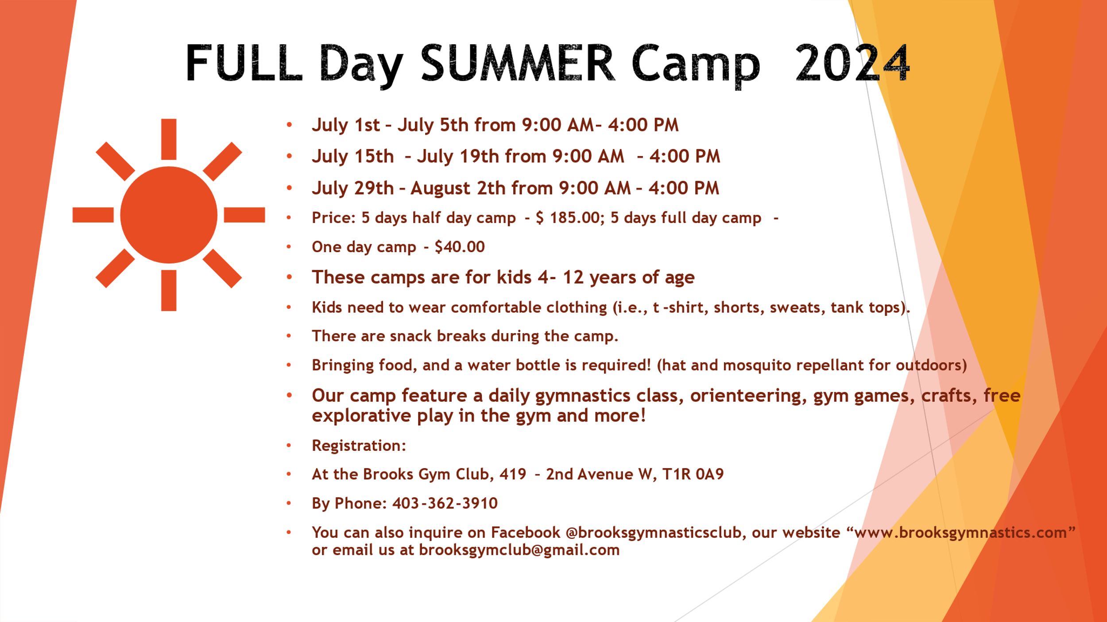

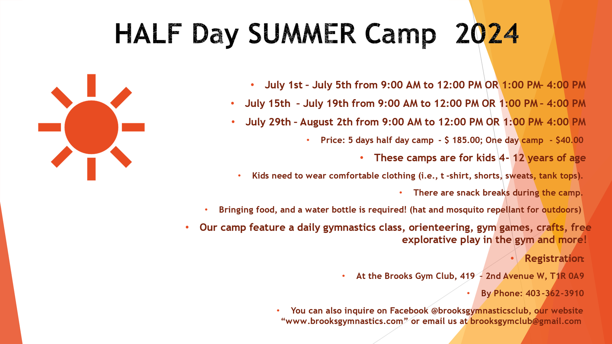

|  |  |  |  |  |  |  |
| --- | --- | --- | --- | --- | --- | --- |
| A picture containing text  Description automatically generated  SUMMER 2024 Participant Registration Form | | | | | | |
| Gymnast’s Last Name | **First Name** | | **Date of Birth (YR/MO/DY)** | | **Sex: M F** | **Alberta Health Care Number** |
| Mailing Address | | | | | | **Postal Code** |
| City/Town | | | | | | **Email** |
| Parent or Guardian | | | **Residence Phone** | | **Cell Phone** | **Notice:** Gymnastics activities, by their nature, involve certain elements of risk which involve a potential for bodily injury. A portion of the registration fees paid to the Alberta Gymnastics Federation (AGF) is allocated for the provision of accident insurance should such injury occur. I acknowledge this element of risk and agree to permit my child to participate. |
| Any Known Medical Problems or Physical Impairments (prescribed medications/etc.) | | | | | |
| Emergency Contact (other than parents) | | | **Residence Phone** | | **Cell Phone** |
| Class Selection  Half day Camp/ Kinder Gym /Preschool/ Rec Beginners/Rec Intermediate/Rec Advanced/Trampoline/ Tumbling Class  *Mon. *Tues. *Wed. *Thurs. * Friday | | **Enrolment Length** | | **Current Date** | **Parent Signature** | |
| Payment (to be completed by Brooks Gymnastics Club):  Class Fee: $ _____________  Yearly Membership Fee $ 77.00 (includes AGF Fee) (AGF # if already paid)  Adjustments $ _____________ Reason: _______________________  Total: _____________ Cash Cheque # ________ e – Transfer  * Any outstanding fees from prior sessions must be PAID IN FULL prior to registration. | | | | | **AGF Fee Chart**  **Parent & Tot Drop-In AGF Fee $ 15.00**  **Preschool Classes/CanGym (Burgundy-Bronze) $45.85**  **Trampoline/Tumbling Classes $45.85**  **Competitive Level 1 & 2 $45.85**  **Competitive Level 3 - 8 $296.75** | |
| **Completed Forms:**  Personal Information Protection Act (PIPA)  Notification and Assumption of Risk, First Aid, Liability | |